Cataracta, a new monotipic genus segregated from Physalis L. (Solanaceae)
Pilar Zamora-Tavares, Mahinda Martínez and Ofelia Vargas-Ponce
APPENDIX
TABLE A1. GenBank sequence numbers of the 22 species used in the phylogenetic inference to estimate the position of Cataracta gen. nov. *cpDNA sequences that were extracted from plastomes generated by Sandoval-Padilla et al. (in prep.). Accession numbers in bold were newly generated for this work. NA = not available.
Species | ITS | GBSSI | LEAFY | matK | rbcL | ndhF | rpl32-trnL | trnL | ycf1-3
Alkekengi officinarum | AY665850 | AY665931 | MH822152 | EF438924 | U08617 | U08927 | MH045575 | MH752594 | MH045575
Brachistus stramonnifolius | AY665845 | AY665924 | MH822159 | OR400638* | OR400638* | OR400638* | OR400638* | EU580963 | OR400638*
Calliphysalis carpenteri | AY665852 | AY665932 | MH822160 | OR400639* | OR400639* | EU580926 | OR400639* | EU581042 | OR400639*
Capsicophysalis potosina | OK298970 | OR521018 | NA | OR521018 | OR521028 | OR521030 | OR521009 | NA | OR521000
Capsicum | AY665841 | AY665923 | NA | JQ589211 | JX856306 | U08916 | NC018552 | NC018552 | NC018552
Cataracta microphysa comb.nov. | AY665859 | AY665933 | MH822240 | OR521029 | OR520999 | OR521033 | OR521017 | MH752653 | OR521008
Chamaesaracha coronopus | AY665860 | AY665937 | MH822163 | OR521022 | OR520991 | EU580871 | OR521010 | MH752598 | OR521001
Chamaesaracha rzedowskiana | OK298969 | OR521019 | MH822166 | OR521023 | OR520992 | OR521031 | OR521011 | MH752601 | OR521002
Iochroma | AY665840 | AY665921 | DQ301559 | EF438902 | NA | EU580894 | NA | NA | NA
Deprea | AY665839 | AY665919 | NA | NA | NA | EU126022 | NA | NA | NA
Leucophysalis grandiflora | AY665846 | AY665929 | DQ301515 | OR521024 | OR520993 | EU58090 | OR521012 | EU581013 | OR521012
Leucophysalis nana | AY665847 | AY665928 | NA | NA | OR520994 | EU580906 | OR521013 | EU581014 | NA
Oryctes nevadensis | AY665864 | AY665934 | NA | OR360845* | OR360845* | EU580923 | OR360845* | EY581039 | OR360845*
Physaliastrum heterophyllum | KC768878 | NA | NA | OR521025 | OR520995 | KC768882 | OR521014 | KC768880 | OR521004
Physalis campechiana | AY665867 | AY665936 | MH822226 | OR521026 | OR520996 | NA | NA | MH752638 | OR521005
Physalis cinerascens | AY665885 | AY665971 | NA | OR296713* | OR296713* | OR296713* | OR296713* | MH752640 | OR296713*
Physalis melanocystis | AY665865 | OR521020 | MH822239 | OR521028 | OR520998 | NA | OR521016 | MH752652 | OR521007
Physalis pubescens | AY665917 | AY665951 | MH304895 | MH045576 | MH045576 | MH045576 | MH045576 | MH752660 | MH045576
Quincula lobata | AY665863 | AY665935 | MH822257 | OR521027 | OR520997 | EU580936 | OR521015 | MH752668 | OR521006
Schraderanthus viscosus | AY665848 | AY665927 | NA | OR360844* | OR360844* | OR360844* | OR360844* | OR360844* | OR360844*
Tzeltalia amphitricha | AY665853 | NA | NA | OR360842* | OR360842* | OR360842* | OR360842* | OR360842* | OR360842*
Witheringia solanacea | AY665858 | AY665926 | DQ301517 | JQ594187 | JQ594188 | U72755 | OR400643* | EU581074 | OR400643*

TABLE A2. Voucher information of the specimens that were used to generate the new DNA sequences.
Species | Specimen voucher | Collected by | Collection date | Country | Identified by | Herbarium
Capsicophysalis potosina | 331 PZT | Pilar Zamora y Mahinda Martinez | 02-sep-16 | Mexico | Mahinda Martinez | IBUG
Cataracta microphysa comb.nov. | 330 PZT | Pilar Zamora y Mahinda Martinez | 02-sep-16 | Mexico | Pilar Zamora | IBUG
Chamaesaracha coronopus | 300 PZT | Pilar Zamora y Mahinda Martinez | 16-sep-16 | Mexico | Mahinda Martinez | IBUG
Chamaesaracha rzedowskiana | 227 PZT | Pilar Zamora y Mahinda Martinez | 21-sep-12 | Mexico | Mahinda Martinez | IBUG
Leucophysalis grandiflora | 1424418_NY | H.H. Bartlet and J.F. Grayson | 27/06/1952 | USA |  | NY
Leucophysalis nana | 2781262_NY | A. Tiehm 17631 | 10/08/2016 | USA |  | NY
Physaliastrum heterophyllum | 1992_MO | Tayaping Team Exp. 791 | 1992 | China |  | MO
Physalis campechiana | SN IBUG | F. Ventura A | 04-dic-71 | Mexico | Mahinda Martinez | IBUG
Physalis melanocystis | SN IBUG | Mahinda Martinez | 17-ago-21 | Mexico | Mahinda Martinez | IBUG
Quincula lobata | 335 PZT | Pilar Zamora y Mahinda Martinez | 16-sep-16 | Mexico | Pilar Zamora | IBUG

TABLE A3. Dataset by regions, number of taxa of Physalidinae included, length in base pairs, and the best-fitting nucleotide substitution models based on the Akaike Information Criterion (AIC).
Data set | Number of Physalidinae taxa | Length in base pairs | Best model (AIC)
5.8S RNA ribosomal | 19 | 703 | HKY+G
LEAFY | 13 | 2141 | GTR+I+G
GBSSI region between exons 8-10 | 18 | 773 | TPM2uf+G
matK | 18 | 789 | TVM+G
ndhF | 17 | 758 | TPM1uf+G
rbcL | 19 | 607 | HKY
rpl32-trnL | 18 | 1213 | TPM1uf+G
trnLF | 16 | 1028 | GTR+I+G
ycf1-3 | 17 | 809 | GTR+G

FIGURE A1. The best tree obtained with Maximum Likelihood and 1000 bootstrap iterations with data of RNA ribosomal 5.8S region and 19 taxa of Physalidinae.
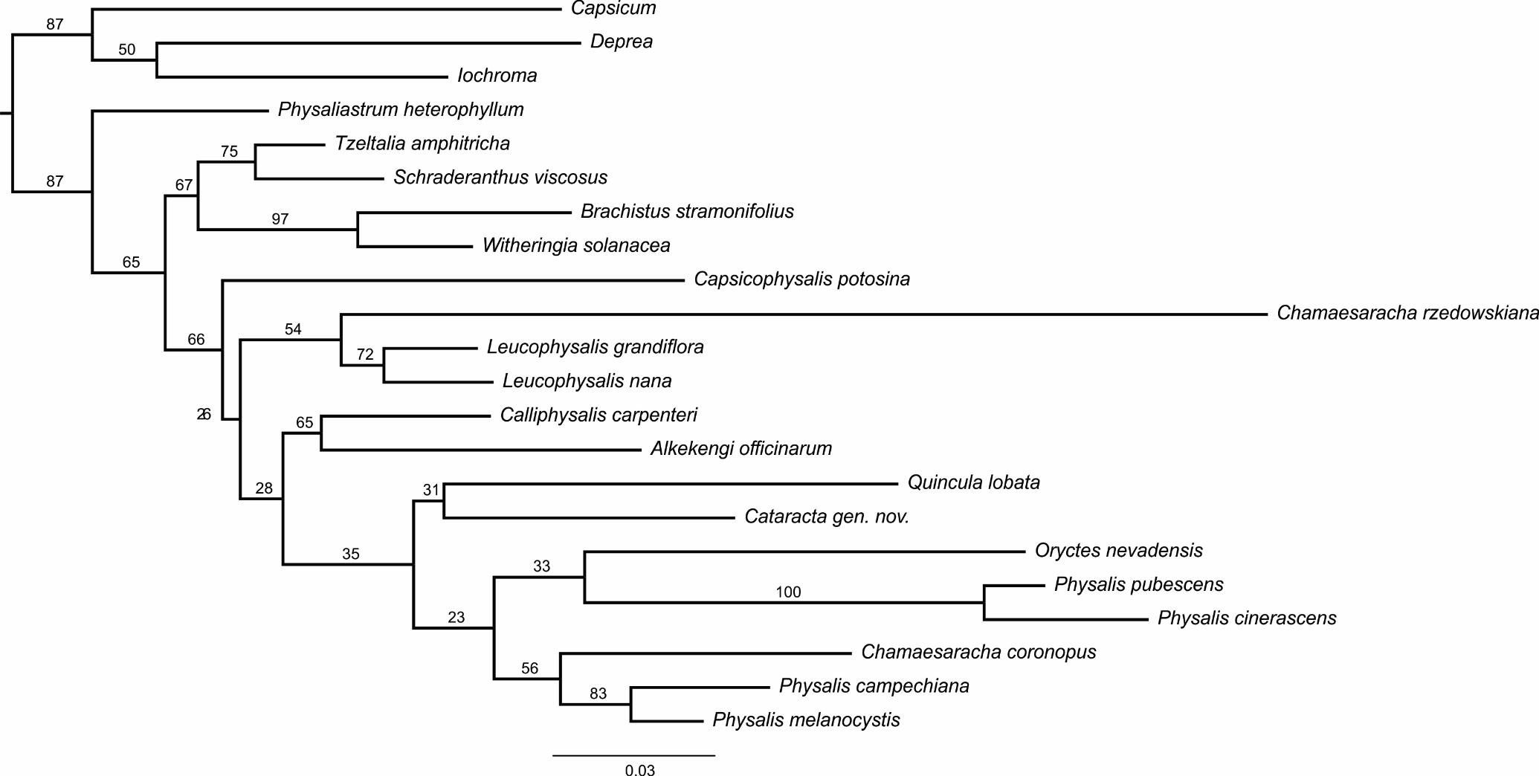

FIGURE A2. The best tree obtained with Maximum Likelihood and 1000 bootstrap iterations with data of LEAFY and 13 taxa of Physalidinae.

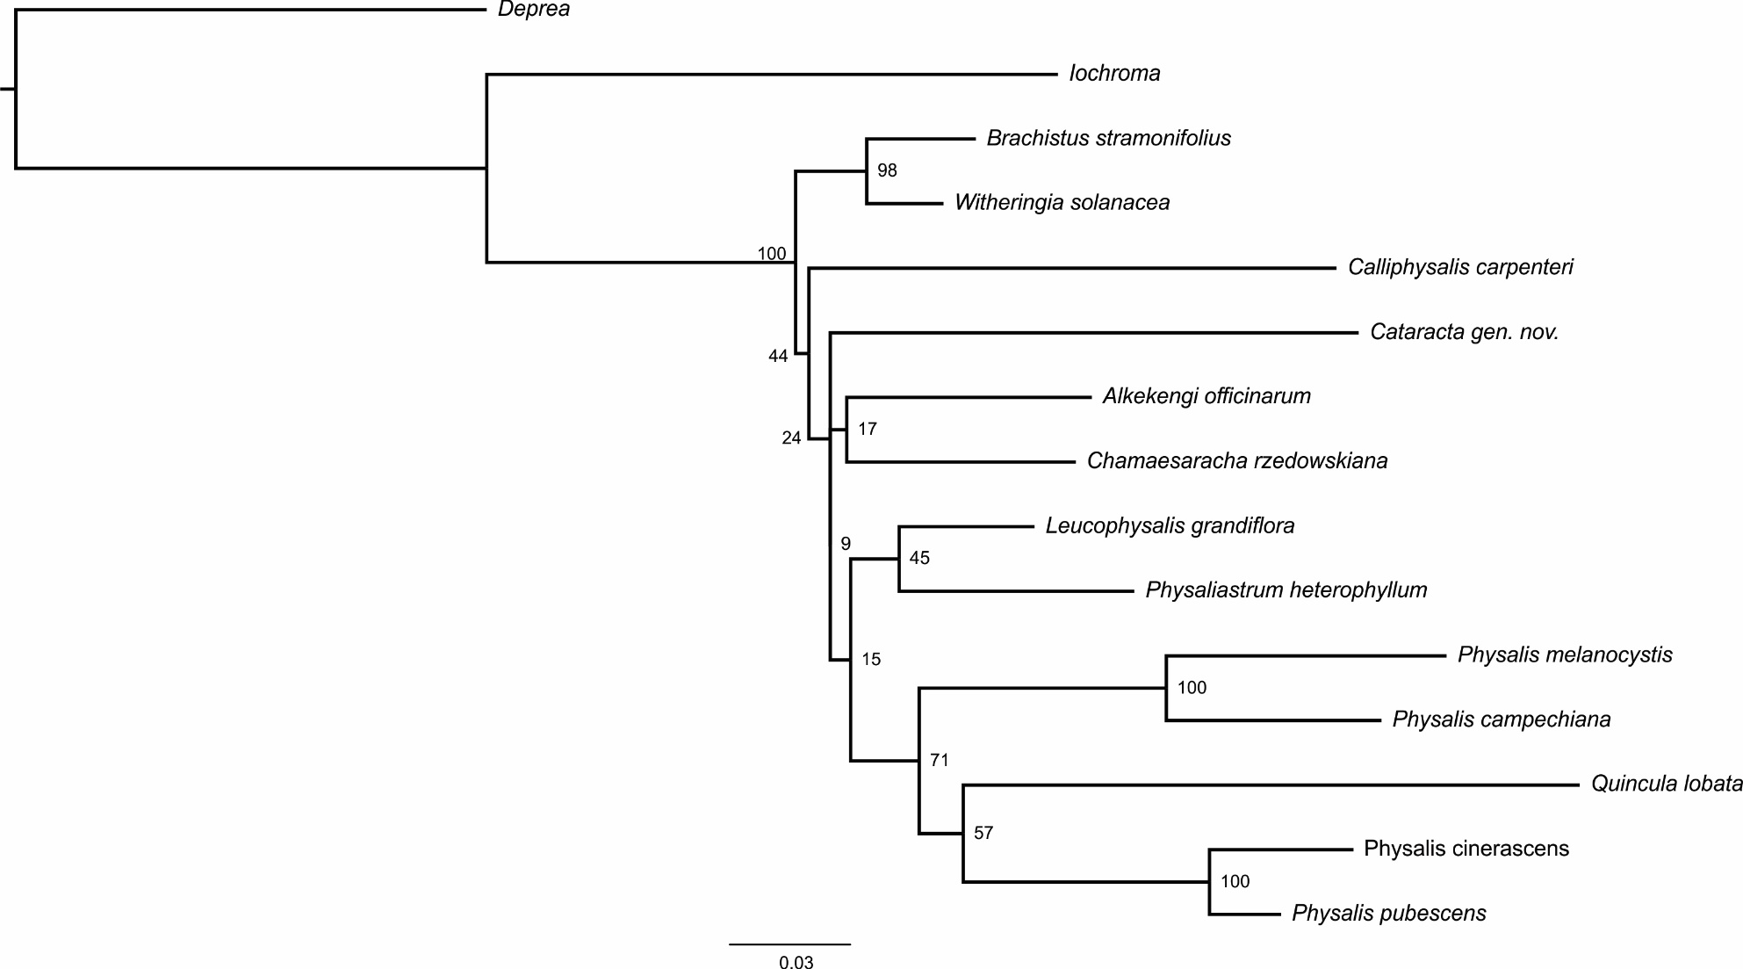

FIGURE A3. The best tree obtained with Maximum Likelihood and 1000 bootstrap iterations with data of GBSSI region between exons 8-10, and 18 taxa of Physalidinae.

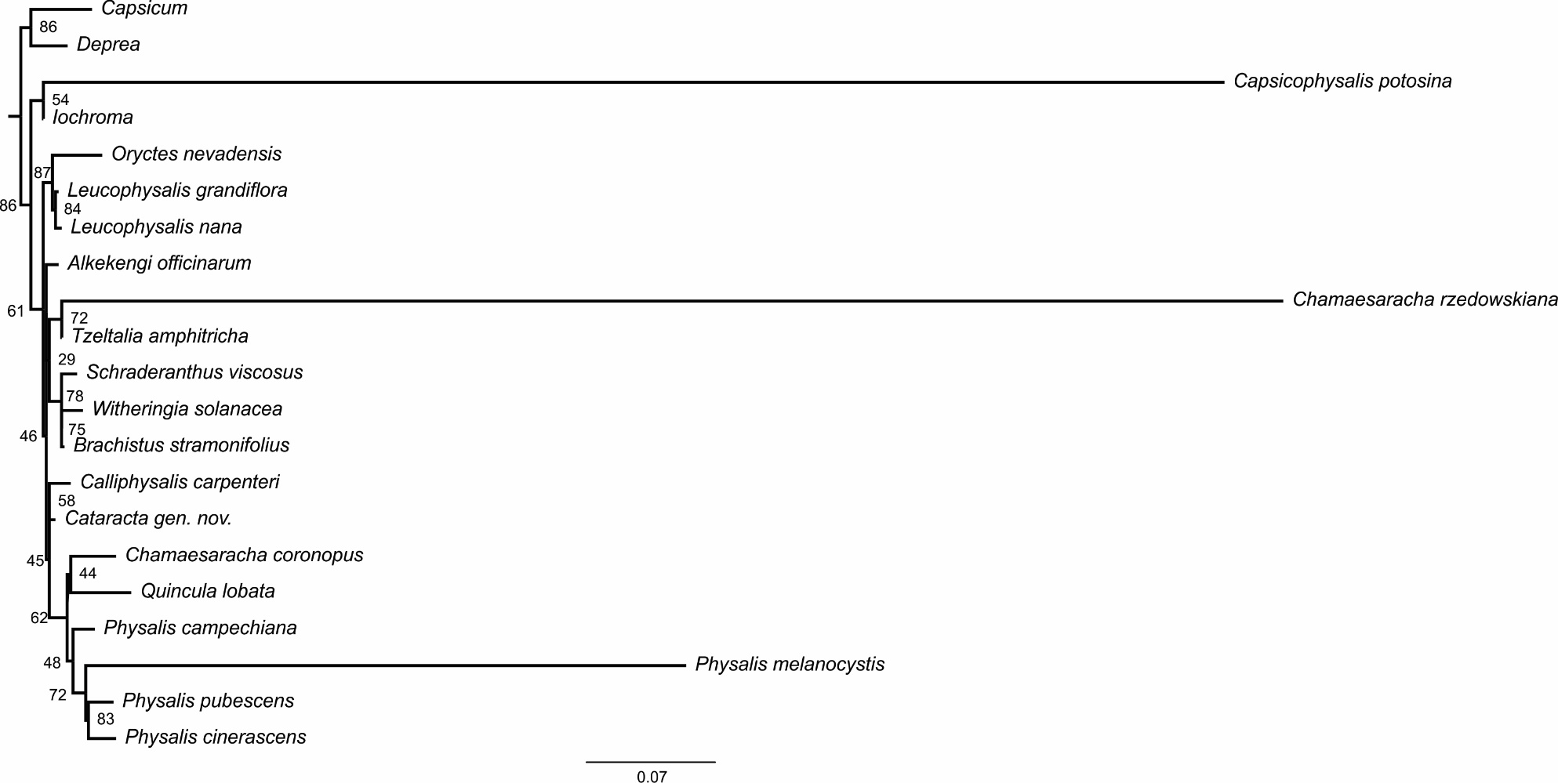

FIGURE A4. The best tree obtained with Maximum Likelihood and 1000 bootstrap iterations with data of matK region and 18 taxa of Physalidinae.

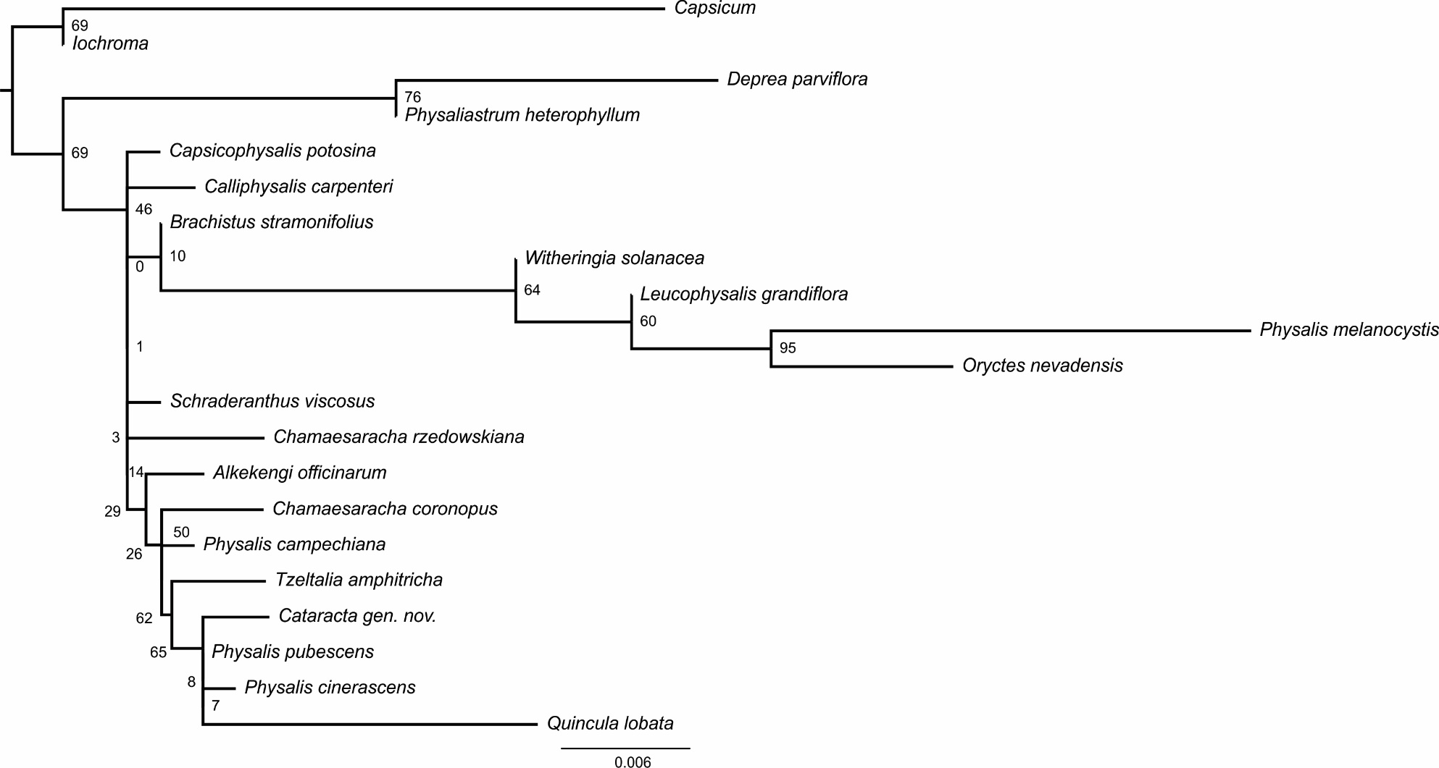

FIGURE A5. The best tree obtained with Maximum Likelihood and 1000 bootstrap iterations with data of ndhF region and 17 taxa of Physalidinae.

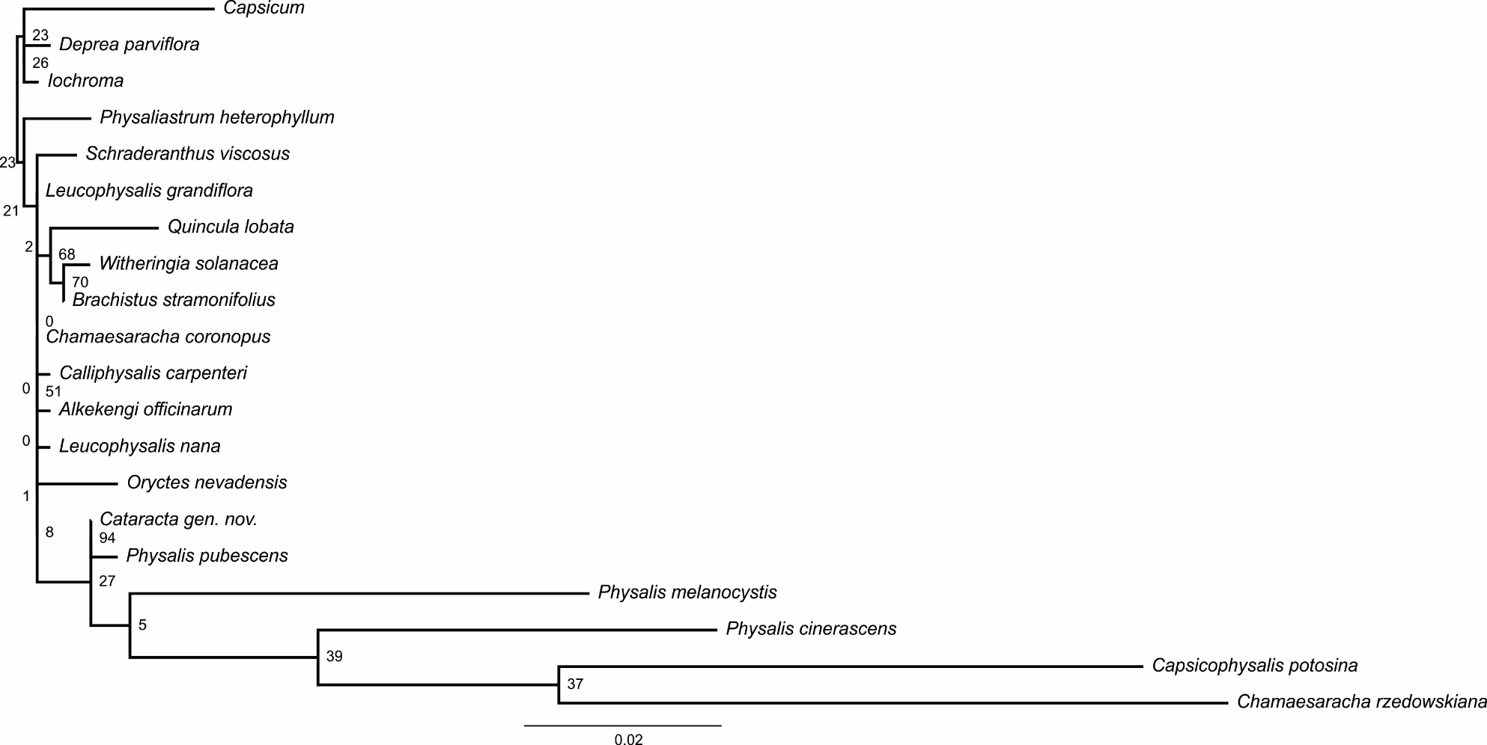

FIGURE A6. The best tree obtained with Maximum Likelihood and 1000 bootstrap iterations with data of rbcL region and 19 taxa of Physalidinae.
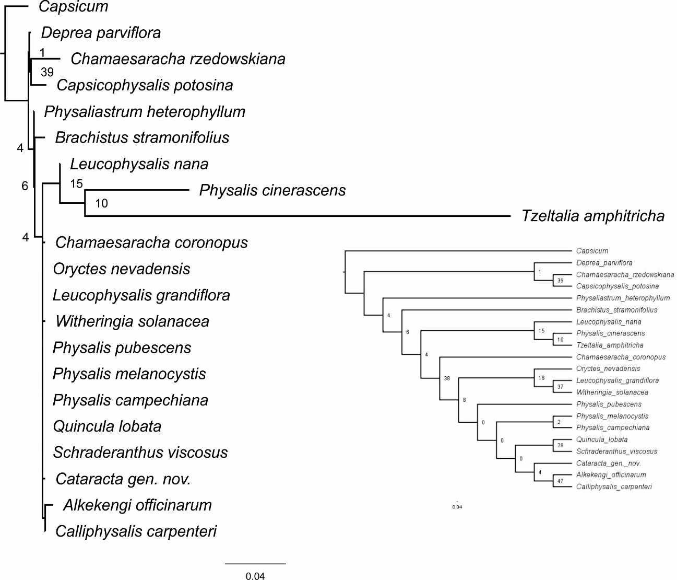

FIGURE A7. The best tree obtained with Maximum Likelihood and 1000 bootstrap iterations with data of rpl32- trnL intergenic region and 18 taxa of Physalidinae.
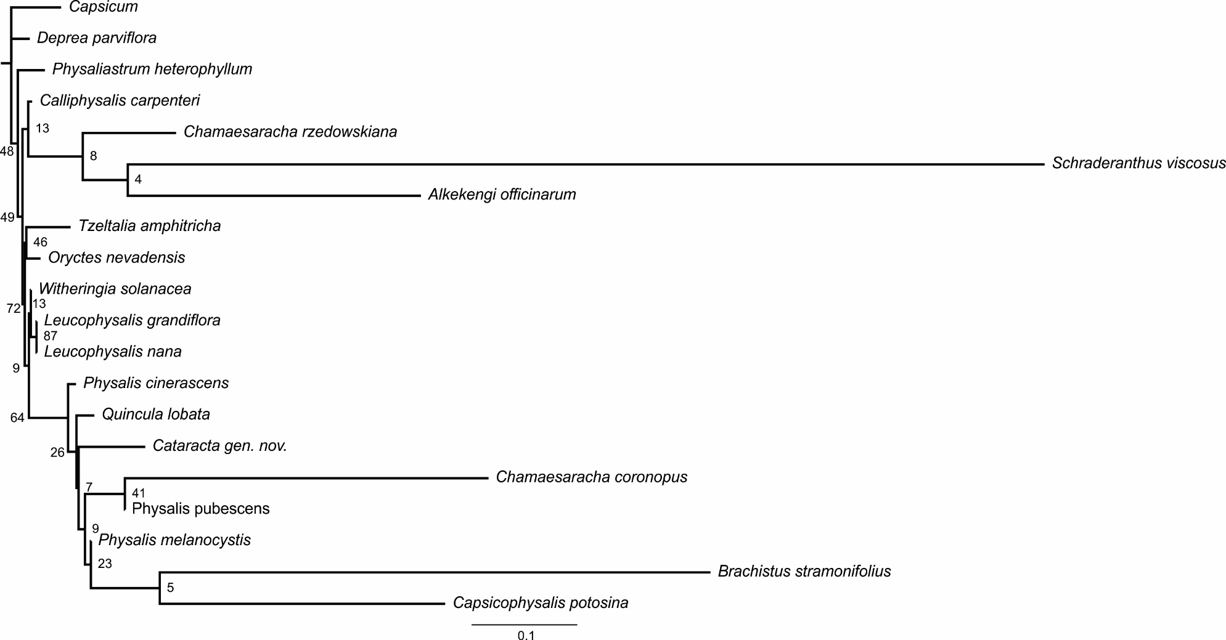

FIGURE A8. The best tree obtained with Maximum Likelihood and 1000 bootstrap iterations with data of trnlF region and 16 taxa of Physalidinae.

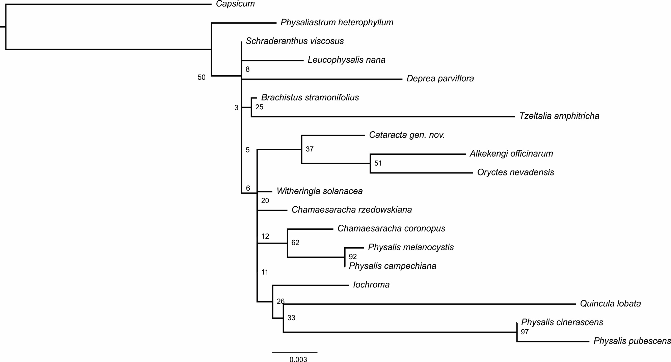
FIGURE A9. The best tree obtained with Maximum Likelihood and 1000 bootstrap iterations with data of ycf1-3 region and 17 taxa of Physalidinae.
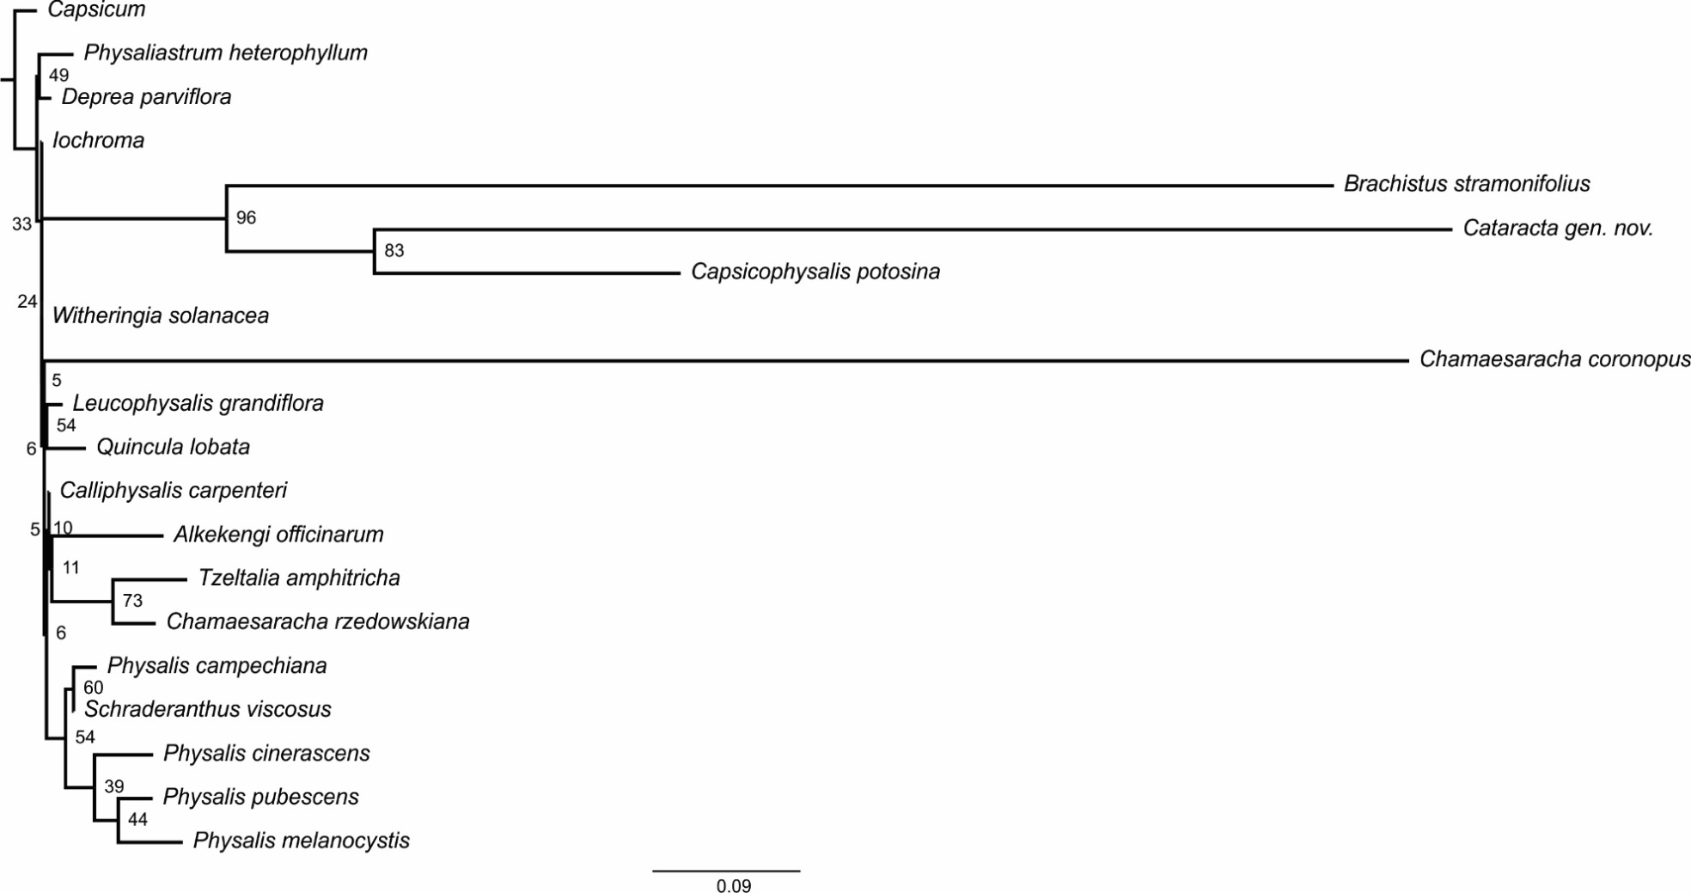

FIGURE A10. Phylogenetic relationships of Physalidinae based on Bayesian 50% majority consensus tree and Maximum Likelihood with data of six cpDNA and three nDNA regions. The colored boxes indicate the subgeneric classification of Physalis proposed by Martinez (1998) and the phylogenetic position of Cataracta gen. nov. Numbers in the nodes are posterior probabilities and bootstrap values.
